Assignment 3

Splay_experiment

***Random seed***: 23

**Random test:**

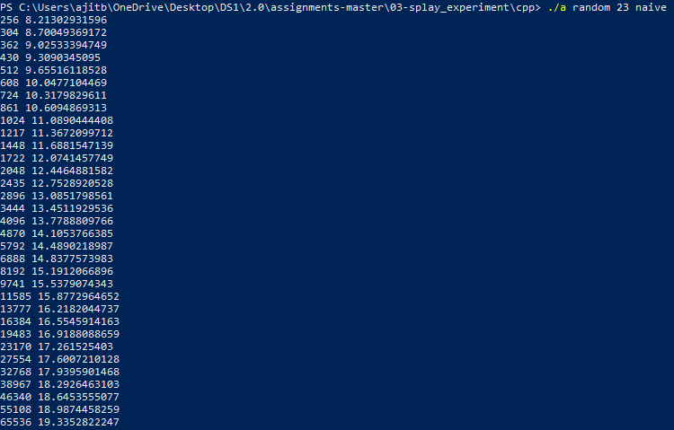

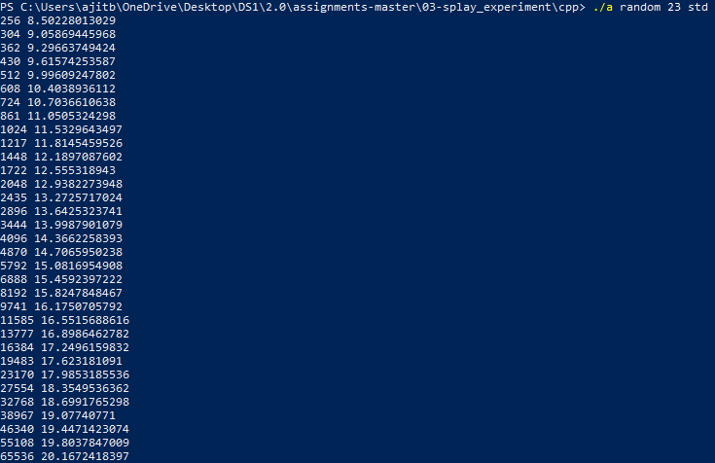

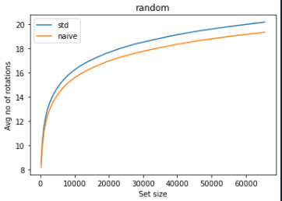

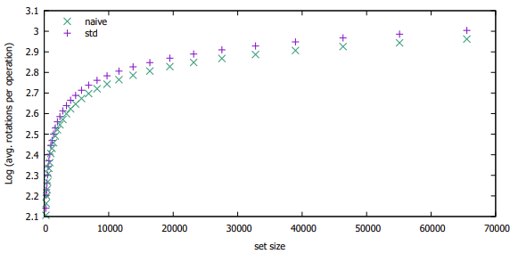

From the resulted output, we can see that the implementations are quite similar with number of rotations, where the plot of std is slightly above naive that the results of naive and std are quite similar.

**Sequential test:**

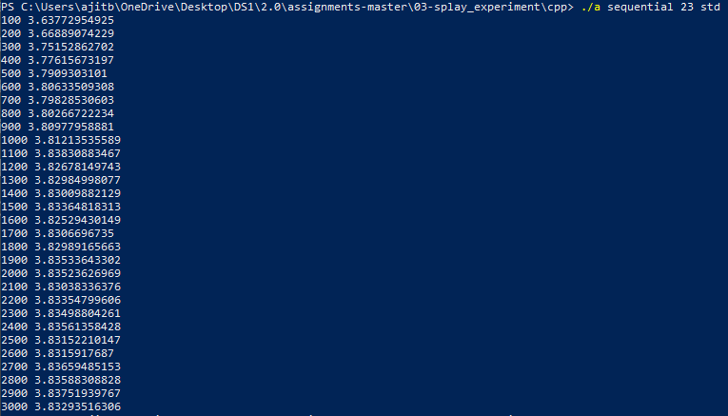

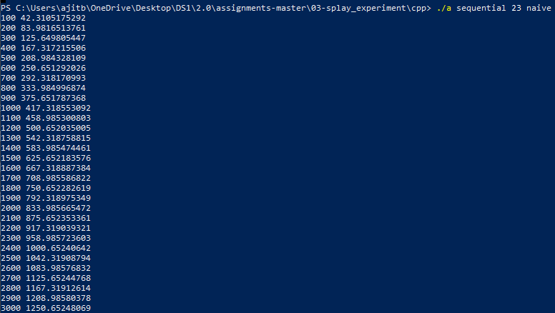

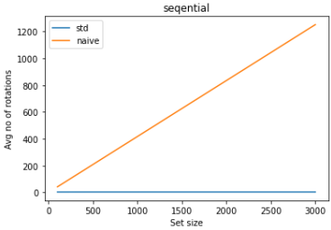

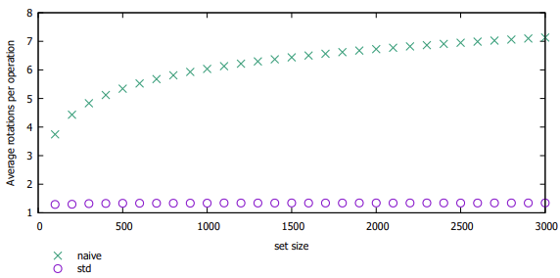

In contrary from the result of random test, the experiment of sequential test between std and naive results with massive difference. In both processes, the complexity of adding n elements in O(n) is constant to one element, with the number of rotations. In case of complexity of finding an element in naive experiment, as the result produced was very accurate linear approximation which I believe to be O(n). I'm not sure about the complexity of the std experiment, but as the graph gives a linear representation, I believe it to be O(n) as well.

**Subset test**:

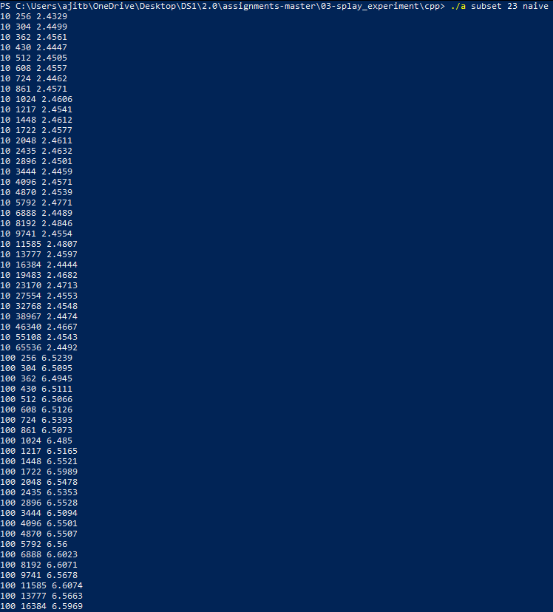

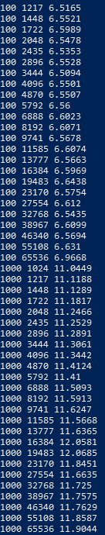

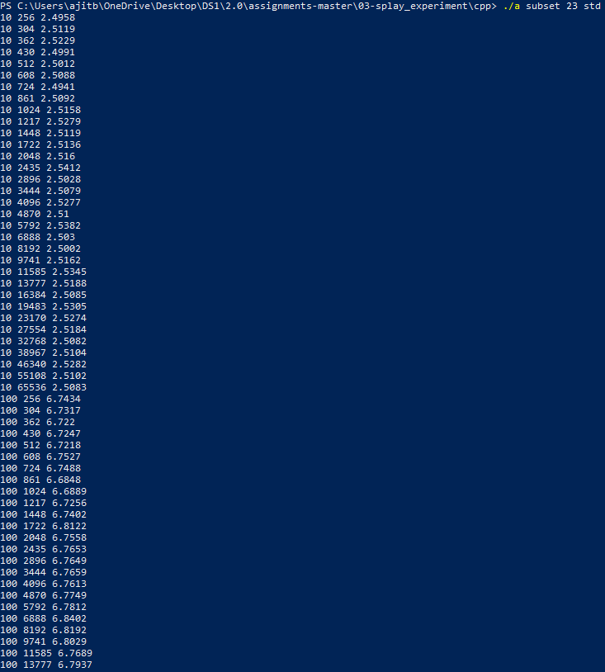

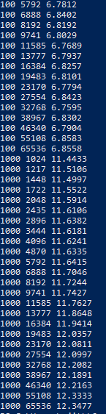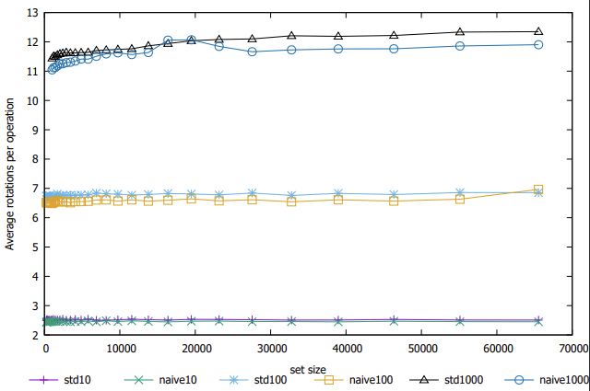

From the result, we can see that the subset result is quite similar to random test where the plots of naive and std are quite similar. Which can be said that the number of trees does not have any effect on the number of rotations for the subset test.